PROMOTEPREVENT COMMISSION MOTIONS, December 2017
MOTION 1: RECOMMENDING POLICIES
Reps. Cantwell and Ferguson and Senator O’Connor move that the Commission recommend general policy changes, not name or recommend any filed legislation.
RATIONALE: A standard practice for many Commissions is not to name specific bills as part of recommendations. This will not prevent us from reviewing and recommending policies embodied in any particular bill.

MOTION 2: ADOPTING DEFINITIONS FOR KEY TERMS
Reps. Cantwell and Ferguson and Senator O’Connor move that the Commission adopt the following key terms for the purposes of developing recommendations (as defined by the U.S. Substance Abuse Mental Health Services Administration & the Institute of Medicine):
- Behavioral Health Promotion: strategies designed to create environments and conditions that support behavioral health and the ability of individuals to withstand challenges.

- Prevention: interventions intended to prevent or reduce the risk of developing a behavioral health problem, such as underage alcohol use, prescription drug misuse, and illicit drug use.

- Continuum of Behavioral Health Care:
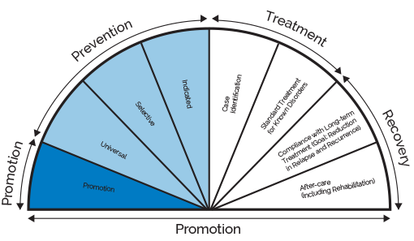
- Universal, Selective, and Indicated Levels of Prevention:
Universal interventions take the broadest approach and are designed to reach entire groups or populations. Universal interventions might target schools, whole communities, or workplaces.
Selective interventions target biological, psychological, or social risk factors that are more prominent among high-risk groups than among the wider population. Examples include prevention education for immigrant families with young children or peer support groups for adults with a family history of disorders.
Indicated interventions target individuals who show signs of being at risk for a disorder. These types of interventions include referral to support services for young adults who violate drug policies or screening and consultation for families of older adults admitted to hospitals with potential alcohol-related injuries.”
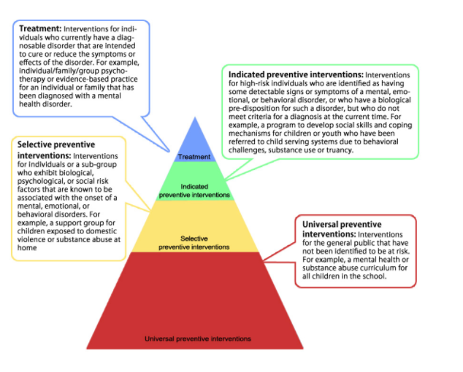
RATIONALE: These terms have come up throughout our meetings. However, there is variation in definitions and understanding. Shared definitions will support deliberations.

MOTION 3: FOCUSING ON YOUTH AND THOSE WHO SERVE THEM
Reps. Cantwell and Ferguson and Senator O’Connor move that the Commission focus on policy or systems changes, practices, or programs that will (1) promote social, emotional, and behavioral health and prevent behavioral health problems among youth, ages 0-22; or (2) target those parents, caregivers, professionals, schools, or communities who serve said youth so those servants may work to promote behavioral health, prevent disorders, or intervene early when elevated risks associated with the onset of mental, emotional, or behavioral disorders are exhibited.
RATIONALE: The primary priority from citizen and expert testifiers in public hearings has been on youth-focused prevention. Youth prevention and promotion programs and policies have the greatest potential for impact and funding. For example, programs like the 1st Grade Good Behavior Game can have sustained measurable effects into adulthood on a range of behavioral health issues for participants regardless of their economic or social background. The group discussion on this topic has largely settled on the side of focusing on youth. Failing to narrow our scope has the potential to overwhelm our deliberations, report, and capacity for change.

MOTION 4: FOCUSING DIRECTLY ON BH PROMOTION AND PREVENTION
Reps. Cantwell and Ferguson and Senator O’Connor move that the Commission target policies, programs, and practices that directly promote behavioral health, prevent diagnosable disorders, or support appropriate early intervention behavioral health services for those at-risk of developing disorders or problems; and further, though recognizing the importance of the full continuum of care, that the Commission not pursue recommendations to (1) improve the recovery, acute treatment, or general social service support systems for people with diagnosed disorders; or (2) make other general social policy changes not directly focused on behavioral health which exceed the Commission’s expertise or legally mandated scope.
RATIONALE: The mission of the Commission, as detailed in the enacting legislation, is to focus on behavioral health. The Commission does not have the in-house expertise or time to hear testimony on, understand, and make expert recommendations about how to change broader social policy. Moreover, wading into the debate around, for example, wage or housing issues (laudable initiatives) stands to 1) expend our limited capital to create change and 2) to ignore our central behavioral health focus. Other organizations and advocates on both sides of social policy debates will no doubt expend enormous resources to address and advocate for these topics—we would be expending our limited voice on an already raucous debate.

RESULTS: Motions were unanimously approved by all Commissioners, Dec. 2017

https://www.samhsa.gov/capt/practicing-effective-prevention/prevention-behavioral-health/risk-protective-factors

